Bearing type selection

Index
1. Scope 3
2. Definitions 3
3. Introduction 4
4. Bearing type experimental analysis 4
4.1. Bearing stability 6
4.1.1. Resonance 7
4.1.2. Stability 8
4.2. Application of experimental results for bearing evaluation 10
5. References 11

Scope
This procedure defines a recommended criterion, intended for implementation during the initial design stages, for the selection of radial sleeve bearings. It is not intended as a substitute for detailed rotordynamic verification, which remains imperative in subsequent design phases. This procedure is applicable to pumps equipped with radial sleeve bearings. It is based upon a thorough experimental analysis of the stiffness and damping coefficients of turbine bearings.
This procedure is applicable to Nova Milanese and La Spezia plants.

Definitions
A_{R} Amplitude of vibration [mm]
B Bearing length [mm]
c Radial clearance [mm]
D (R) Bearing diameter (radius) [mm]
h_{o} Minimum oil film thickness [mm]
n Shaft (max) rotating speed [rpm]
p = W/(B D) Mean specific load [MPa]
So = p ψ² / η ω Sommerfeld number [-]
So_{k} = So ω / ω_{k} Relative Sommerfeld number [-]
W Bearing load [N]
δ Rotor static deflection [mm]
η Dynamic or absolute viscosity [cP]
μ = δ / ΔR Shaft flexibility [-]
ρ Unbalance radius [mm]
ψ = ΔR / R Clearance ratio [-]
ω = 2π n/60 Angular velocity [rad/s]
ω_{k} Fundamental cyclic frequency of a rigidly mounted rotor [rad/s]
ω_{k}* Fundamental cyclic frequency of rotor supported by journal bearing [rad/s]
ω_{gr} Stability limits [rad/s]

Introduction
Improper selection and sizing of journal bearings can lead to operational problems, such as vibration amplitudes exceeding permissible limits. The primary phenomena associated with these issues are the critical speed and self-excited vibrations (instability).
Whereas the critical speed of rotation of the rigidly supported rotor is only reduced by the journal bearings, self-excited vibrations have their origin in the anisotropic non-linear stiffness and damping properties of the oil film.
A complete lateral analysis is almost always required for studying critical speed of rotation and stability limits; however, the stiffness and damping coefficients of the bearing must be known.
This procedure outlines the calculations that can be utilised during the preliminary design phase to select the most appropriate bearing type in terms of stability. It is important to emphasise that this criterion does not consider other operating parameters (i.e., minimum oil film thickness, separation between critical speeds and operating speeds, etc...). It is based exclusively on experimental data derived from turbine application and does not include the contribution on stability of the Lomakin effect in the wear rings, thus focusing solely on the behaviour of the bearings installed on a theoretical rigid rotor.
For this reason, a comprehensive rotordynamic assessment is always necessary to validate the design.

Bearing type experimental analysis
This procedure is based on an experimental investigation that evaluates the stability performance of four distinct bearing geometries (Figure 1):
- Circular cylindrical.
- Horizontal pockets.
- Lemon shape.
- Three-lobe.
For these tests, B/D = 0.5 is considered. If the design ratio differs significantly, subsequent stability considerations may no longer apply.
As a general consideration, the oil film thickness is greatly influenced by the selected bearing geometry. The cylindrical bearing, for an equivalent Sommerfeld number, provides the greatest oil film thickness, indicating a higher load-carrying capacity compared to the other types. Conversely, the three-lobe bearing is the most disadvantaged (Figure 2).
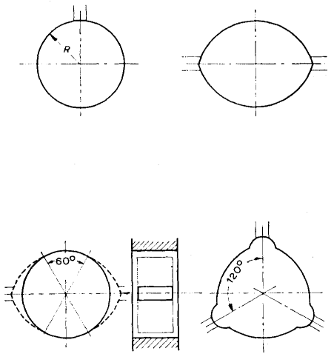circular cylindrical  oil feed | horizontal pockets  oil feed
lemon shape  oil feed |   oil feed  3 lobe
Figure 1: Bearing types.
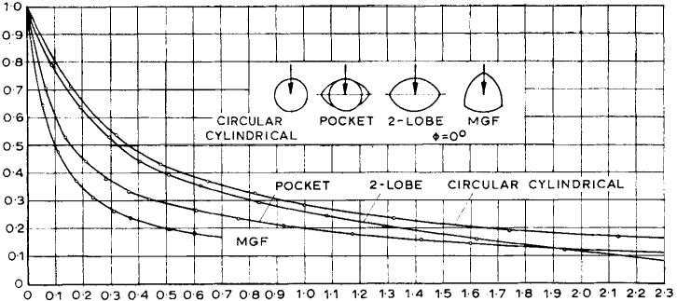
So [-]
h_{o}/ΔR [-]
Figure 2: Oil film thickness.

Bearing stability
The dimensionless number used to characterize sleeve bearings is the Sommerfeld number, which can be calculated using the following formulas:
$$p=\frac{W}{B∙D}$$
$$ψ=\frac{c}{R}$$
$$So=p∙\frac{ψ^{2}}{η∙ω}$$
For the purposes of this procedure, the Relative Sommerfeld number is considered as:
$${So}_{k}=So∙\frac{ω}{ω_{k}}$$
Some technical considerations are deductible from the test results of the reference paper. The vibrational behaviour of a single, symmetrical rotor without journal bearing action is characterized by a critical speed of rotation ω_{k} with a theoretically infinite resonance amplitude: this speed of the rigidly supported rotor is used below as a reference value.
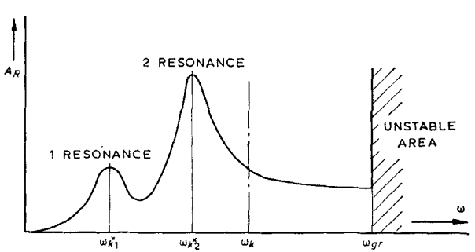
Figure 3: Amplitude of the centre point of the rotor as function of the speed.
The journal bearings substantially vary the vibrational behaviour of such a rotor:
- The critical speed ω_{k} is reduced, and it is often split up into two critical speeds ω_{k1}*and ω_{k2}*.
- The resonance amplitude remains finite.
- The rotor becomes unstable above a certain speed limit ω_{gr}.
The amplitude of the rotor’s centre point, plotted against speed, is schematically represented in Figure 3. The position of the critical speeds and the level of the resonance amplitude are of primary interest in these amplitude curves; also equally interesting is the position of the stability speed limit.

Resonance
The critical speeds and resonance amplitudes of the rotor’s centre point are represented in Figure 4 for the different relevant shaft elasticities μ = δ/ΔR as a function of the relative Sommerfeld number So_{k}.
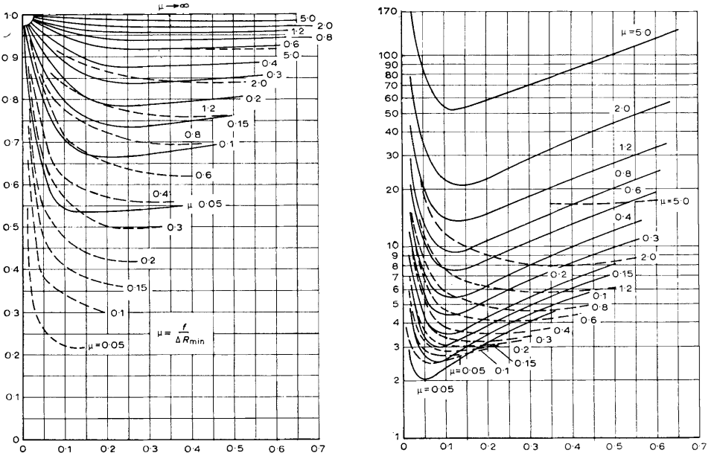
So_{k} [-]
So_{k} [-]
ω_{k}*/ω_{k} [-]
A_{R}/ρ [-]
Figure 4: Critical speed and resonance amplitudes for rotors with pocket bearings.
In this case the rotor is supported by pocket bearings. The two critical speeds (continuous and dashed lines) span over almost the entire So_{k} range, with the higher critical speed usually being the more dangerous. The resonance amplitude of the rotor’s centre point, which is relative to the unbalance radius ρ, has a distinct minimum level.
It can also be seen that the resonance amplitudes increase sharply as the relative shaft elasticity μ increases. A reduction in the resonance amplitude is therefore attainable by decreasing the So_{k} (for So_{k} > 0.2), through higher oil viscosity, wider and/or large bearing, etc…
The rotor's critical speed can be adjusted by changing the shaft elasticity μ. If resonance occurs, altering the bearing clearance, for example, can shift the rotor out of resonance and into a safe operating range.

Stability
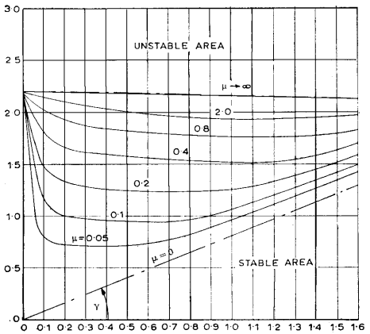
As previously mentioned, a rotor running on journal bearings above a certain speed limit becomes unstable. These stability limits are plotted against the relative So_{k} in Figure 5 for a single rotor running on circular-cylindrical bearings. The various curves demonstrate the influence of the relative shaft elasticity μ. The curves for the very flexible rotor (μ→∞) and for the rigid rotor (μ→0) are plotted by chain-dotted lines in this diagram, representing asymptotic limiting values.
So_{k} [-]
ω_{k}∗/ω_{k} [−]
Both these asymptotic curves delineate the area in which all stability limits lie. Stability always prevails, therefore, beneath the limit curve μ→0, irrespective of the rotor and bearing characteristics.
Figure 5: Stability limits of a rotor for the circular bearing.
Instability is distinguishable from resonance by the frequency of vibration. When there is instability, the frequency of the self-excited vibration is always lower than (or equal to) half the rotational frequency of the rotor. To be more precise, for speeds less than twice the critical speed of the rigidly supported rotor, this frequency is approximately equal to half the rotational frequency, and for speeds more than twice the critical speed, it is equal to the fundamental (actual) frequency ω_{k}.
The stability limits ω_{k}*/ω_{k} were plotted against the relative Sommerfeld number So_{k}. This representation shows the starting curves (So_{k} = constant) as vertical straight lines. Therefore, this diagram shows very clearly at what speed a given rotor reaches the stability limit.
This figure clearly illustrates how an unstable rotor can be stabilized. To achieve this, two distinct operating regions must be considered. For small Sok values (representing a lightly loaded rotor), stability is improved by increasing the μ value, which corresponds to reducing the bearing clearance. Conversely, for heavily loaded bearings (high Sok values), stability is enhanced by increasing the specific bearing load—achieved by reducing the bearing width—along with lowering the viscosity of the lubricating oil and, most importantly, increasing the bearing clearance.
A particularly interesting feature of this diagram is the slope y of the asymptotic stability limit curve μ→0. This angle provides a very clear measure for the stability characteristics of a bearing. As shown when calculating the propagation of error, the maximum degree of error for these stability limits might be less than 10 per cent. Therefore, it may be noted that already slight variations in the stiffness and damping coefficients produce relatively large deviations for stability limits.

Application of experimental results for bearing evaluation
The previous technical considerations are illustrated graphically in Figure 6. In this diagram, the effect of rotor stiffness is depicted by zones of different colours, each corresponding to a particular bearing type. Below these zones, the bearing operates in stable conditions regardless of the rotor characteristics. To evaluate the bearing stability, it is necessary to determine the ratio between the maximum operational speed and the fundamental natural frequency of the rotor shaft when supported by an ideally rigid bearing, in addition to calculating the relative Sommerfeld number. If the point defined by these parameters lies below the designated coloured zone, the bearing is considered stable.
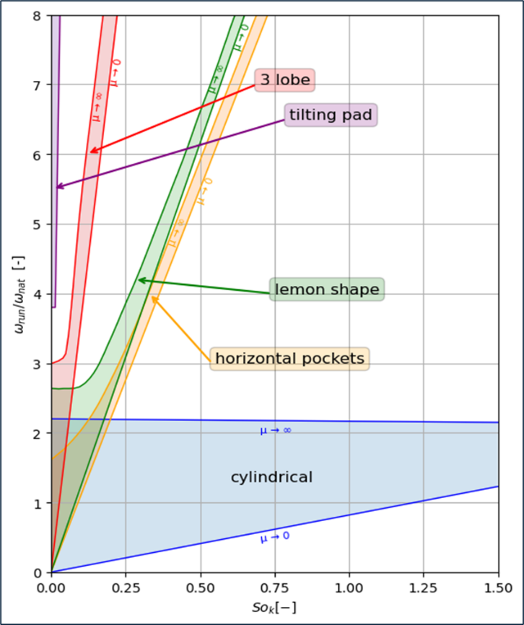
According to the experience of the pump manufacturer, commonly used bearings are:
- Cylindrical bearings (more economical, offering the highest load capacity but more prone to instability).
- Four-lobe bearings (providing good stability).
- Tilting pad bearings (the most expensive, with excellent capability to prevent instability but lower load capacity).
In the graphical procedure previously described, considerations regarding the stability related to horizontal pocket and lemon-shaped bearings can therefore be excluded.
Figure 6: Bearing stability.
A calculation sheet called Mod.556 - Bearing stability criteria is available to perform these calculations.

References
Experimental Investigation of the Stiffness and Damping Coefficients of Turbine Bearings and their Application to Instability Prediction – J. Glienicke
SOP-473 - Lateral analysis - Level 1 – Lateral Analysis First rotor critical speed (simple calculations using standard equation)
Mod.556 - Bearing stability criteria

Some sources define the Sommerfeld number differently, using the inverse of the definition applied in this procedure. It is important to be aware of this difference when analysing data.
SOP-473 - Level 1 – Lateral Analysis First rotor critical speed (simple calculations using standard equation).
Not included in the reference documents.
For four-lobe bearings, the experimental data from three-lobe bearings are considered “still applicable”. Therefore, particular care must be taken under these conditions.

